Animal Welfare

Student’s Name
Institution
Course
Instructor’s Name
Date

Table of Contents
Introduction 3
Association with Meat and Poultry Science 4
Imagery of the Situation 6
Figure 1 6
Figure 2 6
Figure 3 7
Research 7
Overall Conclusions 12
Future Directions 13
References 14

Animal Welfare

Introduction
Human beings benefit a lot from animals including providing them with food, as a source of income and companionship. Furthermore, individuals have been involved with animals for many years during the hunting and gathering stages until now during the civilization process, dealing with animals has increased significantly. Although animals were excluded and were only allowed to live in uncontrolled environments, things have started to change as animal specialists have realized and proved that animals can be treated both psychologically and physically. According to Hemsworth et al. (2015), animal-assisted therapy could help an animal's social skills, moods and feelings of understanding. Moreover, those having companion animals can boost their relationship by providing sufficient welfare. Therefore, animal welfare is a term that was developed to refer to the way animals are handling the situations where they reside. Therefore, they are said to be in virtuous welfare when it is healthy, well-fed, relaxed and can present their distinctive behaviors as well as if the animal is not faced with any kind of anguish from unfriendly conditions including distress, agony and suffering.
Moreover, good animal welfare necessitates disease anticipation and veterinary therapeutic, suitable housing, organization, nourishment humane handling and slaughter. However, currently, people have diverted from these activities and resulted in inhumane care, treatment and husbandry. Therefore, since the responsibility of animal welfare lies in the hands of human beings, this paper will focus on examining human handling and how it is related to meat and poultry science. Additionally, different images will be included concerning meat processing and future directions on the research provided.

Association with Meat and Poultry Science
The world has undergone tremendous change and people have become civilized at the same time population increased. However, the rapid population growth interferes with the ecological requirements which are brought about by the human-induced factors, hence resulting in a reduction in food supply. Nonetheless, the cost of food increases especially meat, thus making poultry meat to be the cheapest meat available as compared to other animals. Meat and poultry science have interfered with animal welfare significantly because it has led to altering the normal habitat and conditions for poultry to grow. For instance, due to increased demand for poultry meat, experts have altered the genetic makeup of poultry and hence ensuring that the animals develop quicker than normal chicken this in return leading to producing contaminated meat that might affect humans.
Moreover, through the meat and poultry science, the natural rearing of chicken is also changed hence affecting their welfare. Considering that there is an increased need for poultry meat, and modifications of chicken genes have been done then they will require a more conventional system that is fully housed. This will have to change the animal depending on the group size, stocking density and ecological control (RSPCA, 2020). For that reason, since fortification of animal welfare includes providing for its physical and mental requirements, there are several viewpoints on animal welfare that are inclined by individuals’ standards and practices and they are measured through productions, behavior and physical responses. Thus, altering the genes of the animal and changing its natural habitats undermines one of the animal welfare principles which states that decisions concerning animal maintenance, practice and welfare shall be completed by matching scientific acquaintance and specialized judgment concerning moral and social standards.
The determination following meat production competences concerning the price and supply of conservative chicken meat manufacturing usually spreads to the management of the resource supply chain which is referred to as vertical incorporation. Vertical integration comprises one firm dealing with refinement, hatching, filtering and provision of foods and medicine and conveyance and slaughter of the chicken. However, other activities such as labor activities are outsourced from farmers who are responsible for the provision of housing, apparatus and labor. Considering different activities are held differently, it is important to consider the safe handling of the chicken meat because different individuals might contaminate the food.
Consequently, the great difference emanating from the local method to meat chicken welfare ascends from not only the ecological variations which include the quality of water and temperature changes. But also, it emanates from changes in the market culture coming from the relations with the vertical integration. Therefore, following the previously states climatic changes, can lead to increased stress factors to poultries hence resulting in poor animal welfare that can lead to augmented vulnerability of poultry to diseases thus causing microbial dangers to individuals. Similarly, poultry well-being and nourishment care are among the critical concerns that need to be addressed in the making of diet of animal sources. The concerns need to be considered as both ethical challenges and food safety problems. For instance, a usual food-borne infection such as campylobacter and Salmonella are the greatest essential pathogens linked to chicken meat processing which are involved in the zoonotic representatives.

Imagery of the Situation

Figure 1
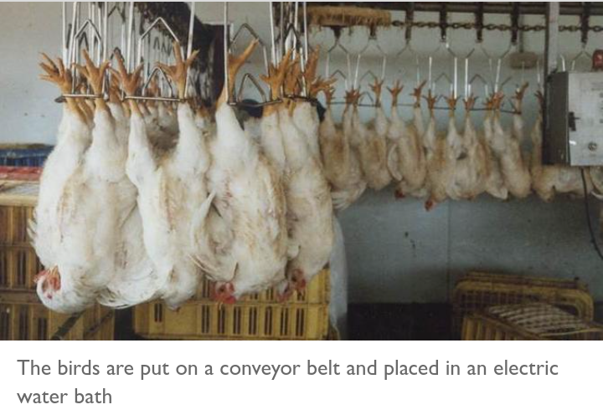
Chicken placed in an Electric Water Bath

Figure 2
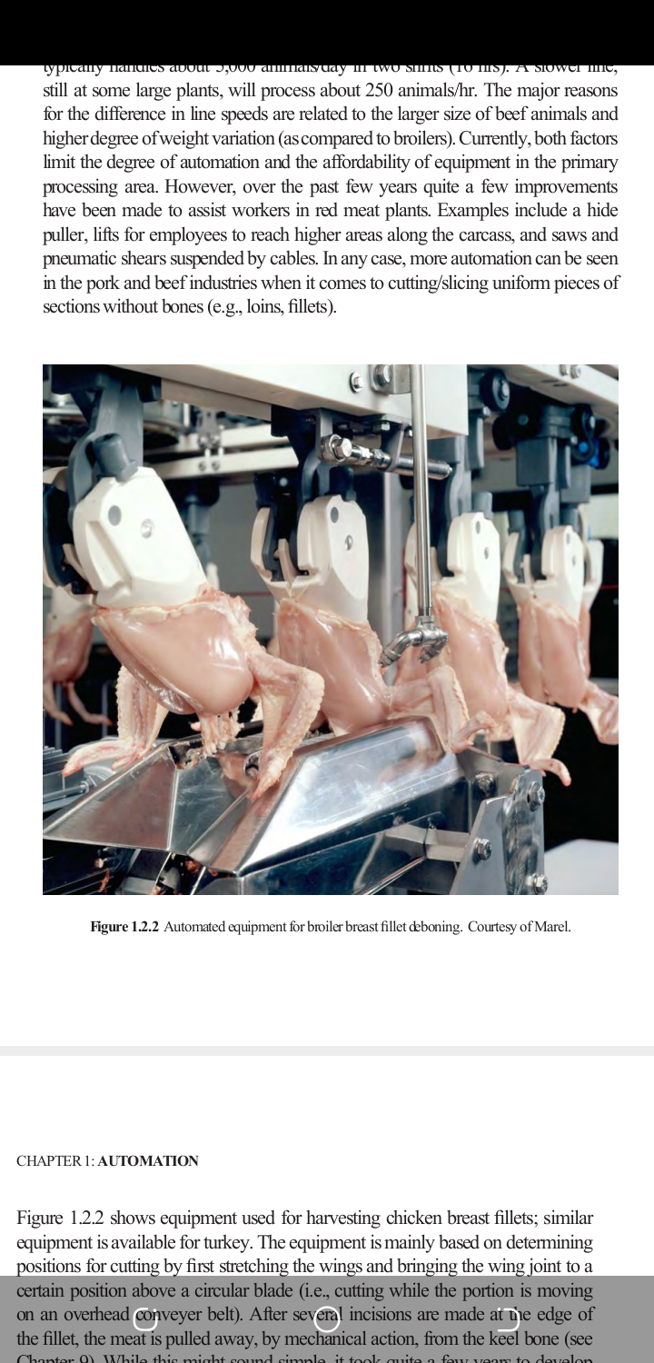
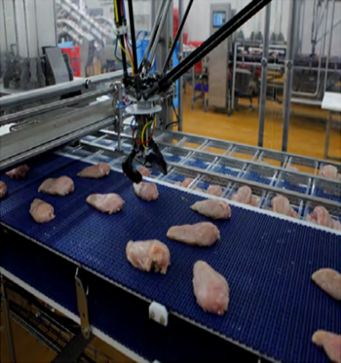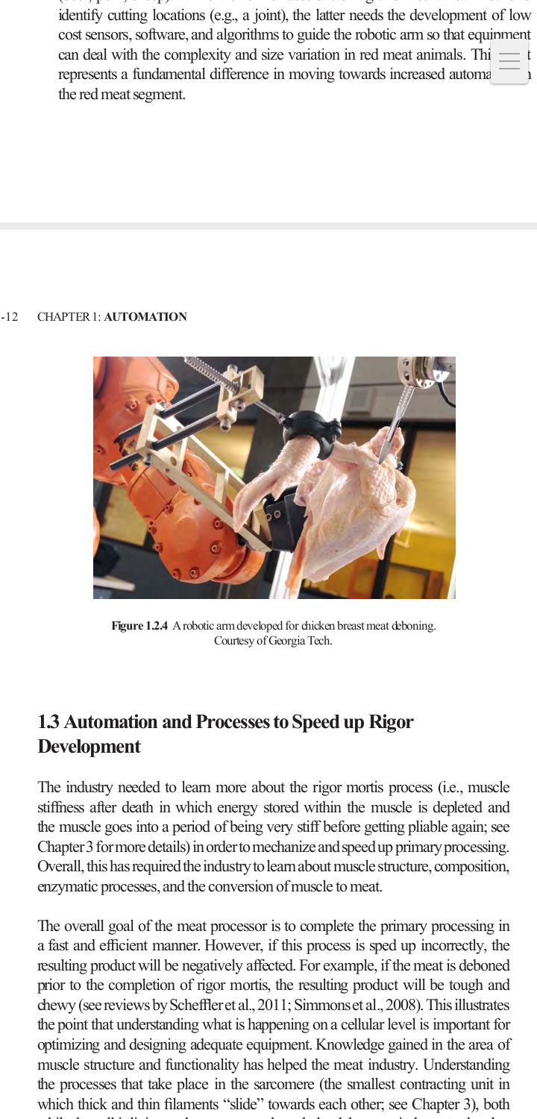
Poultry Automated Processing
Figure 3
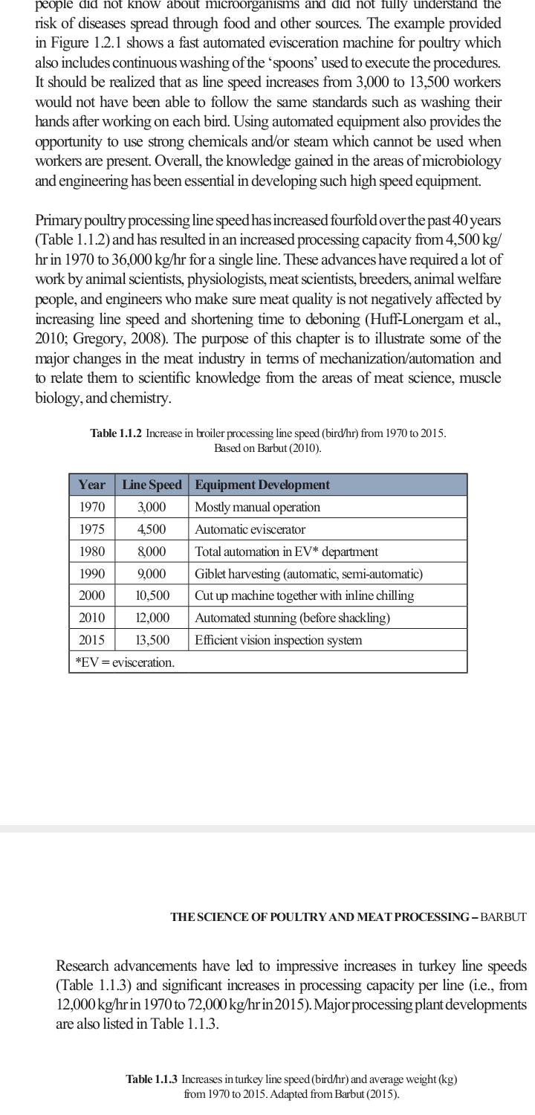
Processing speed increase since 1970-2015

Research
Meat and poultry science have affected animal welfare significantly hence leading to the safety of meat being compromised. Since consumption of chicken meat has increased farmers need to consider other means of rearing them but in a conducive environment as well as in a way that will not interfere with their production and growth system. Animal welfare plays a critical role in getting convenience and quality meat. Research conducted by Iannetti et al. (2020), focused on food control by keeping animal welfare in attention. The authors related several points of animal safety relationship with other farmstead procedures and assessed their effects of Campylobacter and Salmonella fecal peeling and subsequent biological pollution of broiler bodies during the slaughtering process.
The study was conducted on thirteen broiler chickens that were obtained from six different firms in Italy. Although all the chicken were from the same joined poultry firm that controlled the production chain in the points of shading and slaughtering, the farm situations were consistent but changed in different ranches (Iannetti et al., 2020). Two of the chickens were reared by following the European guidelines and procedures such as the principles of 834/2007 and 889/2008 that required the chickens to have the availability of open-air region over modern hovels for a minimum of one-third of their lifetime which is 81 days. Also, broiler chickens over four thousand eight hundred should not be raised in one house as per the guidelines.
Every chicken was tested for Campylobacter while at one month of age to ensure only those that tested positive are used in the research. However, it was essential in understanding if the utilization of animal well-being was significant in making variations to the absorption of Campylobacter in chicken skin. For easy identification, every chicken was attached with a batch number from the farm and only chickens from farm two had three participants because it had one from conventional and the other two from organic. Furthermore, poultry from organic farms was slaughtered during the 83rd and 84th day however, those from conventional were slaughtered between their 42 and 52 days. According to Souza et al. (2015), before any chicken was slaughtered, they had to pass through the animal welfare assessment with the welfare quality standards.
The welfare standards to be considered were good eating, housing, behavior and health. The results obtained supported the theory that body infection at slaughterhouse was inclined by welfare and stress that the chicken is exposed to in their life. Similarly, Campylobacter is inspired by the decrease in welfare scores, especially in the skin. Therefore, the author concluded that when animals experience good welfare as well as a friendly environment then poultry meat will be harmless from biological perspectives and more attractive for individuals’ consumption.
Aghwan et al. (2016), researched the ways of improving meat quality through effective bleeding, treatment and welfare. Following the ancient halal slaughter and other methods of slaughter tailed by religious individuals, there are contrasting influences to pre-slaughter treatment, stress and pain related to limitation. However, although there is a situation where pain cannot be caused then beginning of insentience need to be put in place. The author found out that having an equilibrium with both the bleeding process and the presence of animal well-being was significant (Aghwan et al., 2016). Many practices have been considered to cause harm and stress to the animal before being slaughtered through the utilization of restraining equipment, poultry treatment and effective halal bleeding. Although the study found out that when following effective halal bleeding procedures and animal treatment upholds the quality of meat, there is need to follow the suggested poultry welfare measures to ensure they decrease the suffering and pain of the animals hence resulting in increased meat quality and food safety.
Another research performed by El-Deek, et al. (2019), focused on the behavior and quality of chicken meat under changed housing conditions. One of the most contributing factors to animal welfare is the housing of an animal, thus making poultry houses one of the most controversial issues in the topic. Having reviewed several pieces of literature that provides sanctions on different types of chicken houses whether to use indoor or outdoor, the article has realized that poultry housing condition has a straightforward impact on chicken welfare that can affect their behavior and meat quality in general. Thus, farmers are looking for more detailed information concerning animal welfare, prolific performance, and poultry behavior and meat quality.
Moreover, El-Deek, et al. (2019), identified that almost eighty percent of individuals in the world choose chicken products over other animals’ products that have apparent great quality obtained from organic scheme with augmented welfare values. According to the current intensive production mechanisms, most of the farms which are projected to be around seventy percent have not set standards and resources that will sustain the natural behavioral requirements of the birds. Nevertheless, through outdoor production, the mortality rate of poultry can be over ten percent due to cannibalism. However, proper housing schemes that concentrate on poultry well-being results in better behavioral events and intensified productive performance is essential.
The development of modern breeds of chicken has proven to be effective producers of protein, nevertheless, this modification of breeding and gene alteration has resulted in several consequences on animal welfare. Most of the time the economics of production and apprehension for welfare of the poultry are not encountered. For that reason, to ensure that this is achieved it is important to make animal welfare a sparingly feasible portion of the maintainable, effective poultry production requirements. Similarly, the challenges of providing enough food for the rapidly increasing population as well as, maintaining the environment have led to the increased roles of agricultural professionals in devising sustainable ways that are effective and intensive. Although modern broilers have been developed and increased the rate of production, it is accompanied by several problems of animal welfare and health concerns to people.
Another welfare problem to meat and poultry science is the increased vulnerability to cardiovascular diseases and lameness due to selective breeding. Furthermore, breeding for fast juvenile development rate has resulted in impacts on the welfare of the parent poultry (Kadykalo et al., 2018). Besides, due to lack of food limitations, these chickens always develop obese and experience challenges in movements while their male counterparts have decreased fertility. Similarly, since the breeding and rearing of broilers is increasing substantially the step of food limitation requirement to maintain the broiler breeders on their well-being and healthy development route has intensified. Therefore, the article concluded that farmers need to consider the economic gains obtained by ensuring animal welfare considerations are taken in place, and thus should not be regarded as a single aim secluded from other problems of chicken industry to ensure sustainable agriculture.
According to Dawkins (2017), animal welfare plays an important role in the economic success of farmers. For that reason, when animals are treated well, they will produce more and increase the quality of meat production hence increasing customer satisfaction. The article argues that the possible battle between effective farming methods and animal welfare is fixed through demonstrating financial advantages obtained by enhancing animal welfare to farmers and society in general. Thus, several resources were examined and analyzed to identify the economic benefits obtained after focusing on animal welfare. Meat is a significant topic as poultry farming is done to provide proteins to people, however, the increase in population alters the natural rearing process of chicken and thus requiring new breeds that take less time to mature hence interfering with the animal welfare standards. Some of the benefits obtained when keeping animal welfare are decreased mortality as the animal is maintained in its natural state. Similarly, animals can perish due to pre-slaughter handling events. For example, when sick poultry is not handled well or in case they are being transported under severe ecological situations and traumatic circumstances. Death of poultry animals is the wicked effect of pre-slaughter treatment on the body and meat quality because there is overall damage in the body and meat quality since the animal will be disposed of.
Another advantage of improving animal welfare to farmers is the improved health of an animal as it will not be subjected to activities and events that interfere with its growth. Growth of an animal is substantial in the products and offspring’s being offered. Since the animal will have quality fertility, they will provide enhanced product quality such as meat which will be helpful to individuals. Similarly, welfare leads to enhanced disease resistance and decreased medication as animals will not be susceptible to environments and activities that can lead to illness and stressful events. Furthermore, there is an advantage of reduced dangers of zoonoses and foodborne illness and farmers’ work fulfillment and engagement to commercial societal accountability. Finally, the capacity to ask for more prices is also available due to increased quality of meat products. Nonetheless, the challenges encountered through the animal welfare and meat and poultry industry can be attained by management experiences and involvement of technology.

Overall Conclusions
In summation, animal well-being is a very critical topic that requires special considerations by poultry experts. Although majority of the institutions have taken it for granted it is important in meat quality and health issues in consumers. Many consumers do not concentrate on the quality of the poultry products obtained, however, in case of a change in the taste of the product they will react to it. The development in selective breeding within the broiler birds has resulted in a call for greater effectiveness and supportable escalation. For example, due to increased breeding of the broilers, as compared to the layers, they have managed to increase the speed at which they intensify their weight and they can now be ready for processing within four to five weeks.
Considering the issues that have been presented they include the variations in growth rate, ecological situations inside the shed, stocking density, catch and transport and stunning methods of slaughter. Modern methods of rearing chicken are against animal welfare because they do not consider the four conditions which include good food, health, housing and suitable behavior. For example, rapid growth has led to animal welfare issues because animals are unable to control their fast development leading to heart failure and leg disorders. Similarly, based on the conditions stated, broiler may have toxins in their body hence affecting human health. Moreover, when the ecological situations of the birds shed are not well ventilated it will lead to increased ammonia which might result in eyes and respiratory abnormalities. On the other hand, selective breeding has been achieved and has resulted in increased production of chicken meat, however, this has caused more animal welfare issues that need to be considered to guarantee meat quality.

Future Directions
An increase in poultry production is essential in ensuring food satisfaction to the rapidly growing population, however, considering the animal welfare issues is more critical in guaranteeing people's safety. Safety among individuals is of more importance as it allows them to operate in their daily activities and provide a sustainable environment. Nevertheless, the issue of contaminated poultry meat has been under investigation for several years now which is brought about by animal welfare issues not being taken into considerations. However, there is a need to focus on the suffering of animals during development as it affects the taste of meat as well as its influence on human consumers. This will provide more opening to farmers and other organizations concerned to focus on improving and supporting animal welfare by providing for its physical and mental needs.
To conduct this research the same design method of selecting poultry from different farms and different locations will be maintained to ensure diversity of results, however, the sample size will be increased to ensure convenience and reduction in bias. Obtaining relevant results is key in improving animal welfare and increasing the quality of poultry meat. Higher sample size mandates that the result will be able to represent the whole population to mitigate the limitations of the study, restrictions should be put in place to ensure organic birds are not included as they may interfere with the results.

References
Aghwan, Z. A., Bello, A. U., Abubakar, A. A., Imlan, J. C., & Sazili, A. Q. (2016). Efficient halal bleeding, animal handling, and welfare: A holistic approach for meat quality. Meat science, 121, 420-428. https://doi.org/10.1016/j.meatsci.2016.06.028
Barbut, S. (2015). The science of poultry and meat processing. https://atrium.lib.uoguelph.ca/xmlui/handle/10214/9300
Dawkins, M. S. (2017). Animal welfare and efficient farming: is conflict inevitable?. Animal Production Science, 57(2), 201-208. https://doi.org/10.1071/AN15383
El-Deek, A., & El-Sabrout, K. (2019). Behaviour and meat quality of chicken under different housing systems. World's Poultry Science Journal, 75(1), 105-114. https://doi.org/10.1017/S0043933918000946
Hemsworth, P. H., Mellor, D. J., Cronin, G. M., & Tilbrook, A. J. (2015). Scientific assessment of animal welfare. New Zealand Veterinary Journal, 63(1), 24-30. https://doi.org/10.1080/00480169.2014.966167
Iannetti, L., Neri, D., Santarelli, G. A., Cotturone, G., Vulpiani, M. P., Salini, R., ... & Messori, S. (2020). Animal welfare and microbiological safety of poultry meat: Impact of different at-farm animal welfare levels on at-slaughterhouse Campylobacter and Salmonella contamination. Food Control, 109, 106921. https://doi.org/10.1016/j.foodcont.2019.106921
Kadykalo, S., Roberts, T., Thompson, M., Wilson, J., Lang, M., & Espeisse, O. (2018). The value of anticoccidials for sustainable global poultry production. International Journal of Antimicrobial Agents, 51(3), 304-310. https://doi.org/10.1016/j.ijantimicag.2017.09.004
RSPCA. (2020). What are the Animal Welfare Issues with meat Chicken Farming? https://kb.rspca.org.au/knowledge-base/what-are-the-animal-welfare-issues-with-meat-chicken-farming/#:~:text=These%20welfare%20problems%20include%20leg,to%20access%20food%20and%20water.
Souza, A. D. O., Sans, E. C., Müller, B. R., & Molento, C. F. M. (2015). Broiler chicken welfare assessment in GLOBALGAP® certified and non-certified farms in Brazil. Animal Welfare, 24(1), 45-54. https://doi.org/10.7120/09627286.24.1.045
Webster, B. (2019). Chickens still facing slaughter in pain and fear. https://www.thetimes.co.uk/article/chickens-still-facing-slaughter-in-pain-and-fear-60lgfxd25

